GARDEN CITY UNIVERSITY

SURVEY REPORT
....................................................................................................................................................................................
Submitted By: Ballani Sai Keerthana
Register Number: 24BTCE135
College: Garden City University
Faculty: Swathika Mam
Date of Submission: 27 JAN 2026

Report on Preventive Healthcare Awareness is Low Among the Public

Step 1: Observation Points
- Many respondents are only somewhat familiar with preventive healthcare.
- Most people visit doctors only when symptoms appear.
- Regular health check-ups are not commonly practiced.
- Lack of awareness and time are major barriers.
- People believe preventive healthcare is important but do not follow it regularly.
- Health information mainly comes from doctors and the internet.

Step 2: User Identification
General Public:
Role: Responsible for maintaining personal health.
Expectations: Easy access to affordable preventive care.
Healthcare Professionals:
Role: Provide guidance and awareness.
Expectations: Early diagnosis and cooperation from the public.
Government & Health Organizations:
Role: Promote preventive healthcare programs.
Expectations: Improved public health outcomes.

Step 3: Interviews / Surveys
- How familiar is the public with the concept of preventive healthcare?
- How often do people go for regular health check-ups?
- What do people understand by preventive healthcare?
- What factors prevent people from practicing preventive healthcare?
- How important do people consider preventive healthcare for long-term health?
- From where do people mostly get information about health and prevention?

Summary
The survey indicates that preventive healthcare awareness is low among the public. Even though people understand its importance, they do not prioritize health check-ups or healthy habits. Barriers such as lack of awareness, busy schedules, and cost prevent individuals from adopting preventive practices. This leads to late detection of diseases and increased health risks.

Suggestions from the Survey
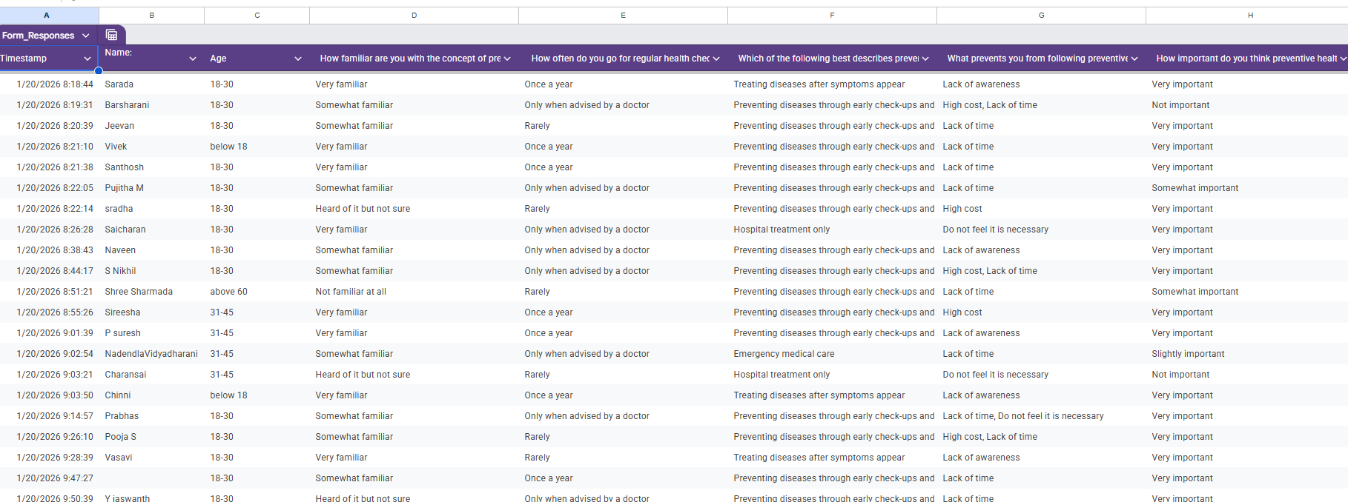
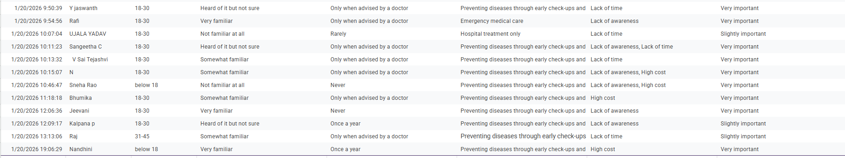
• Conduct awareness programs on preventive healthcare.
• Provide affordable or free health check-ups.
• Use digital platforms for health education.
• Encourage routine screenings.
• Include preventive healthcare education in schools and colleges.

Step 4: Pain-Point Analysis
Functional Pain Point: Low participation in regular health check-ups.
Emotional Pain Point: Fear and neglect toward health.
Systemic Pain Point: Insufficient awareness programs and high healthcare costs.

Most Critical Pain Point
The lack of awareness about preventive healthcare is the most critical pain point, leading to unhealthy habits and delayed medical attention.

Step 5: Root Cause Identification (5-Why Analysis)
• Why do people avoid preventive healthcare?
→ They visit doctors only when sick.
• Why do they delay check-ups?
→ They lack awareness of preventive benefits.
• Why is awareness low?
→ Few organized health education programs exist.
• Why are such programs limited?
→ Treatment is prioritized over prevention.
• Why is prevention not prioritized?
→ Time and cost influence health decisions.

Root Cause Identification
• Lack of proper health education.
• Busy lifestyles.
• High medical costs.
• Limited government initiatives.
• Focus on treatment rather than prevention.

Step 6: Wicked Problem Understanding
Improving preventive healthcare awareness is a wicked problem because it requires changes in public behavior, health policies, and healthcare systems. Balancing costs, accessibility, and continuous education are challenging.

Step 7: Reflection
This study helped to understand the importance of preventive healthcare. The survey highlighted gaps in awareness and practice. User-centered education and policy support are essential to promote preventive healthcare adoption.

